EEM Release Notes

for

Version 3.17 released as of

4/12/2018 11:58 AM

Table of Contents

1. Introduction 3

2. Compatible Products 3

3. Installation Steps 3

4. New Features 3

5. Bug Fixes 4

6. Known Problems and Workarounds 4

# Introduction

This document communicates the major new features, bug fixes and setup changes in this release of the EEM. It also documents known problems and workarounds.

# Compatible Products

This release has been tested on the following platforms and products:

* Windows OS 2012 on the Server
* Windows OS 7.0 on the Client
* MS SQL Server 2012
* Internet Explorer 11

# Installation Steps

* Backup the EEM Production Binaries for future use
* Download the Release rar files from the git hub.
* Stop the EEM Production Website on IIS
* Extract any one rar file which will automatically extract all required EEM binaries and related files.
* After successful extraction, copy the files to the EEM release location on the EEM server.
* Go to the Scripts\Upgrade folder in the released location and run Setup.cmd
* Restart the EEM Production Website on IIS

# New Features

The following new features appear in this release:

***4.1 Feature Description:***Can we have EEM Project Plan to include the PI and Sprint Numbers in assignments window?

*Details*

* + The current assignments are done thru the Project Plan tool and are referring to the Excel to get the right tasks to assign. If we can get the PI and Sprint custom fields on the PP assignments window it will be easy for Scrum Masters to refer to.
  + This requires you to setup the configuration for the custom field columns to be shown in assign window.
  + Use the System Preferences screen, Application tab to make the required change
  + Please select the custom fields that needs to be shown in the Project Plan assignment window. Here is a snapshot of the fields

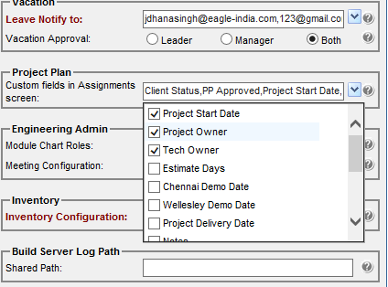

# Bug Fixes

**5.1 Bug Description:** Mail server and other mail notifications should include Business calendar

**Fix**

* + Absence registration from EEM could apply leave and permission on non-working day, its fixed now that it can't be applied on a non-working day.

**5.2 Bug Description:** Absence registration mail text change

**Fix**

* + Mail text has been changed while applying absence registration from

Please be notified that employee will be missing office today in the AM/PM session to

Please be notified that employee will be missing office today during the AM/PM session.

# Known Problems and Workarounds

None